

NOTRE DAME UNIVERSITY
BANGLADESH
CSE-3206 Lab Report-01

Course Title: Operating System Lab
Course Code: CSE-3206

Submitted by:
Name: Istiak Alam
ID: 0692230005101005
Batch: CSE-20
Submission Date: 23-01-25
Lab Task Topic : Familiarization of Linux Commands

Submitted to:
Khorshed Alam
Lecturer, NDUB

- Commands :

  - Creating Files using terminal
Syntex : touch file_name
Command : $ touch Text.txt

Sample Input & Output :

Fig : 1 creating File

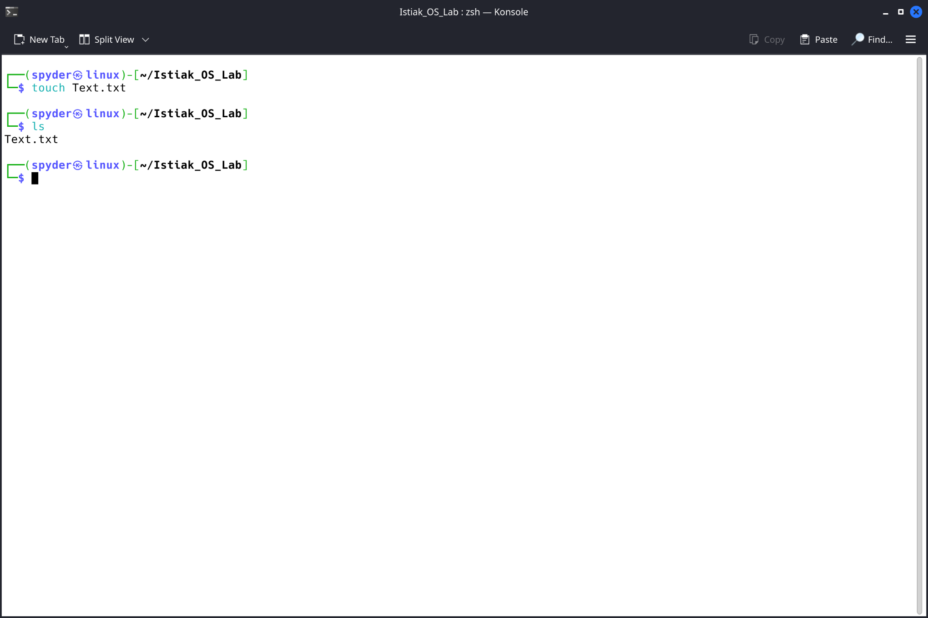

  - Creating Folder using terminal
Syntex : mkdir directory_name
Command : $ mkdir Lab1

Sample Input & Output :
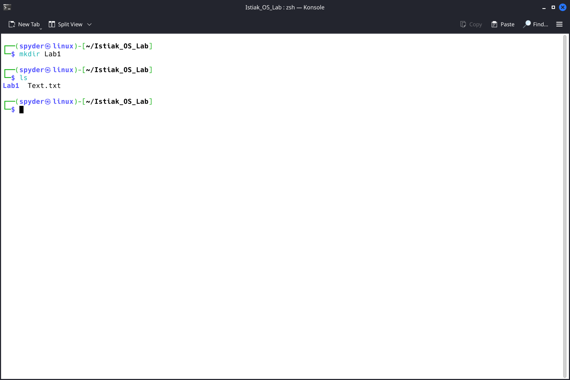

Fig : 2 creating directory

  - Print Current Directory using terminal
Syntex : pwd
Command : $ pwd

Sample Input & Output :
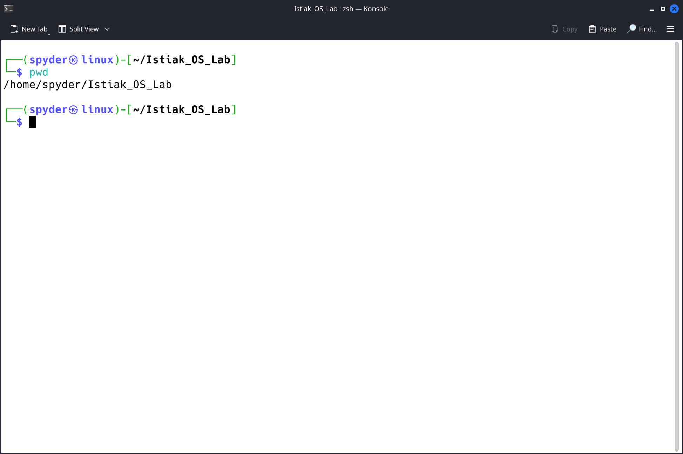
Fig : 3 Current Directory

  - Change Directory using terminal
Syntex : cd directory_name
Command : $ cd Lab1

Sample Input & Output :
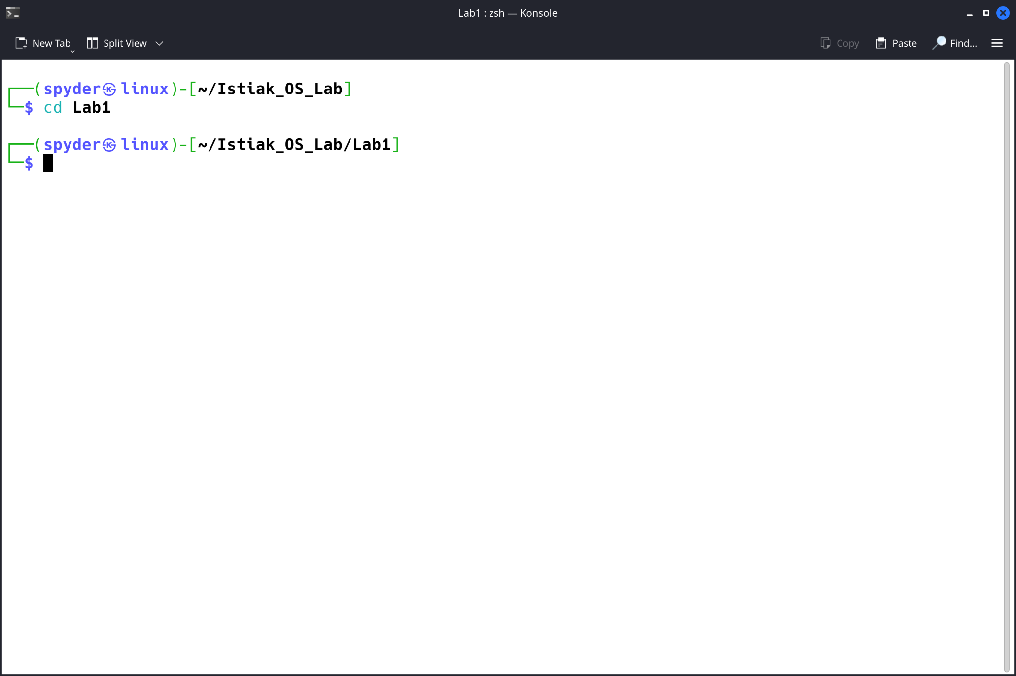

Fig : 3 Current Directory

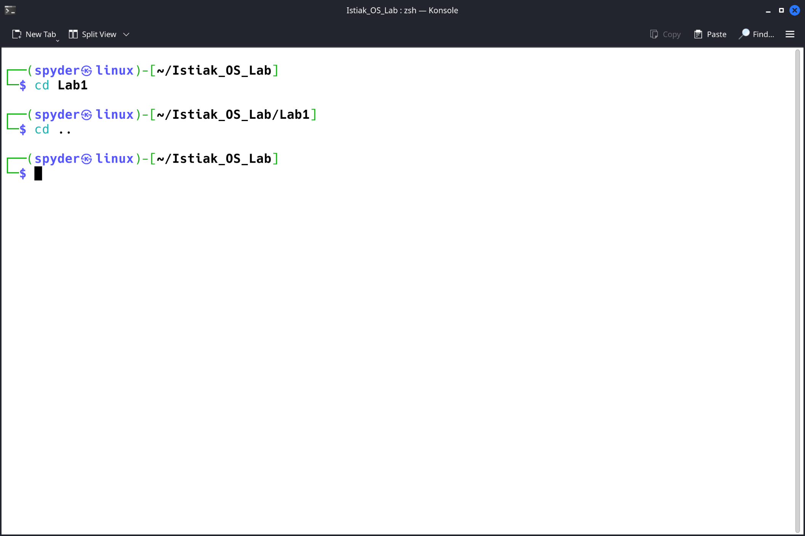

Fig : 3 Current Directory

  - Print Content using terminal
Syntex : cat file_name
Command : $ cat Text.txt

Sample Input & Output :

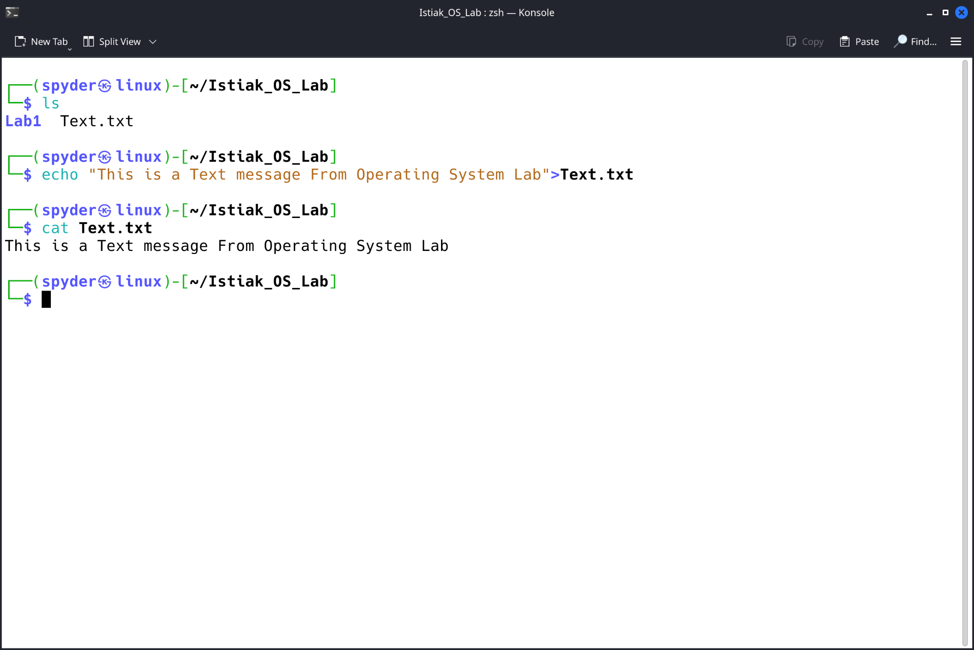
Fig 4 : cat

